**>>Create one VPC,with 1 one public subnet and 1 private subnet.**

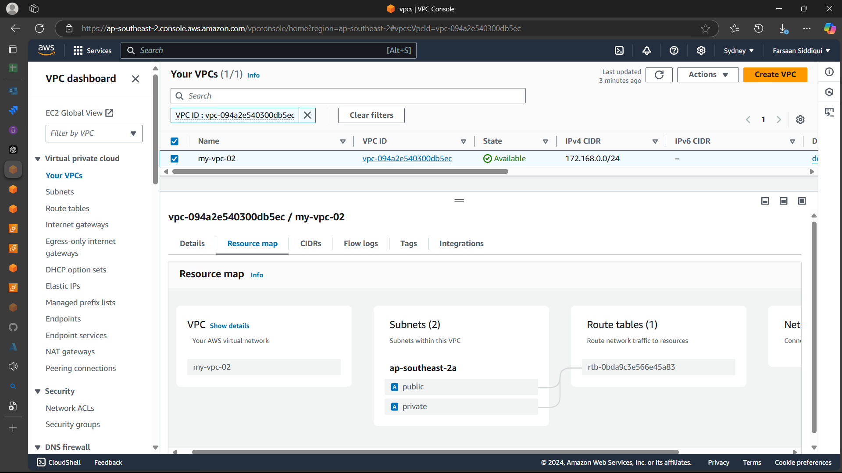

**>>Enable VPC peering for cross region.**

go to vpc and click peering > create peering connection > fill the details > add the vpc from the remote server then sent the request > accept the request from remote server > add ip in route table in both servers.

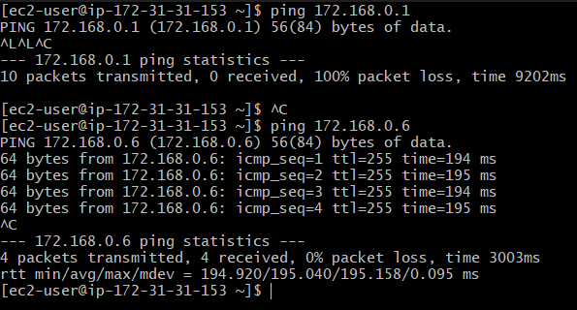

**>>Enable VPC peering for cross account. (You can collaborate with your friend and do this task).**

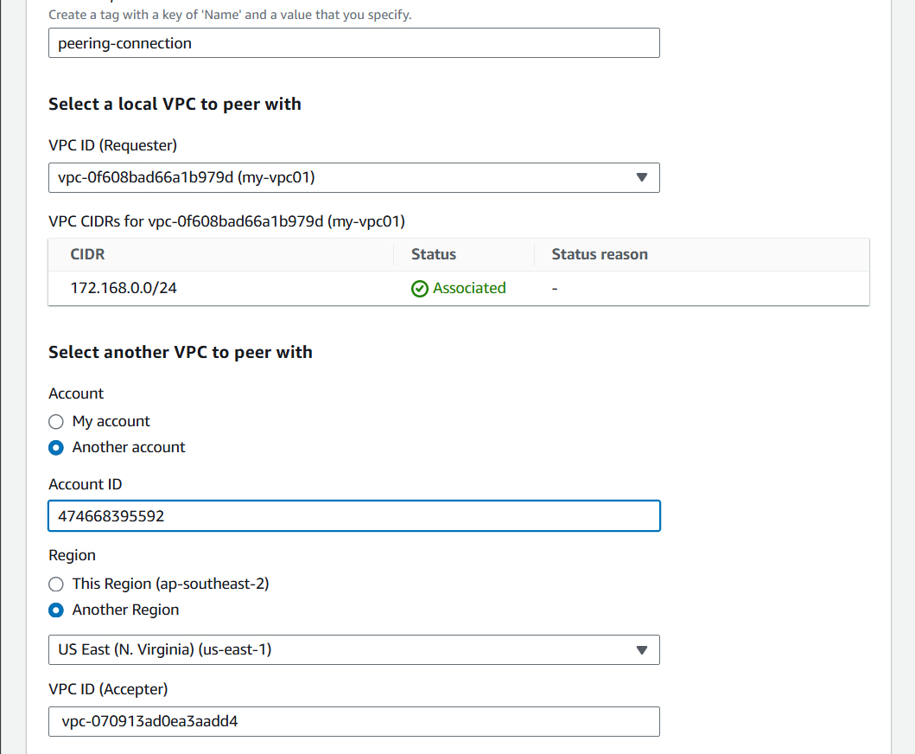

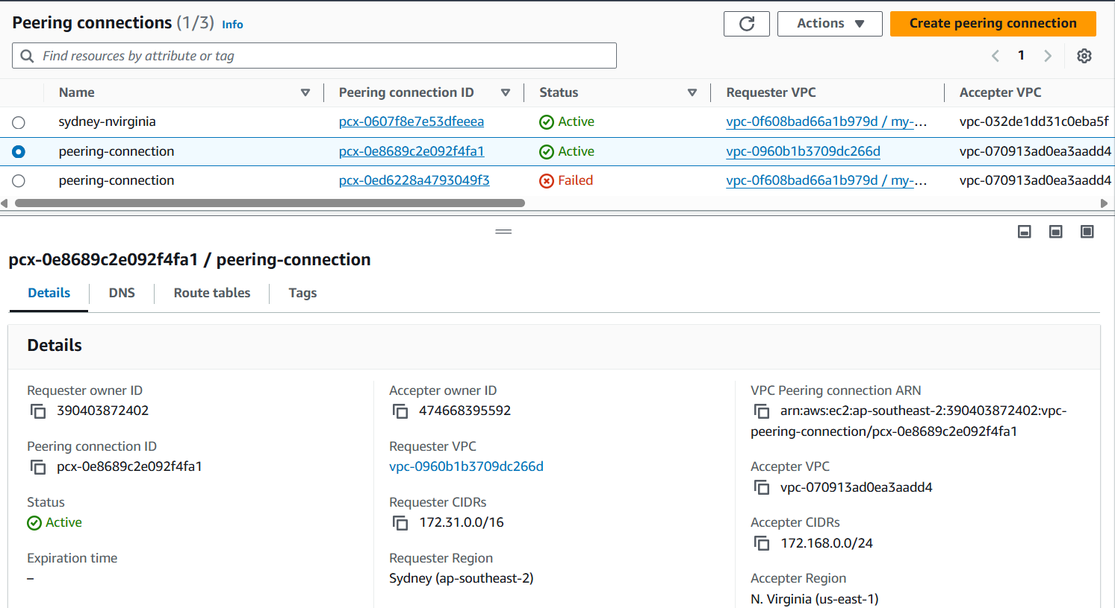

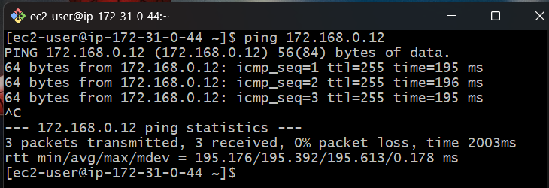

**>>Setup VPC Transist gateway.**

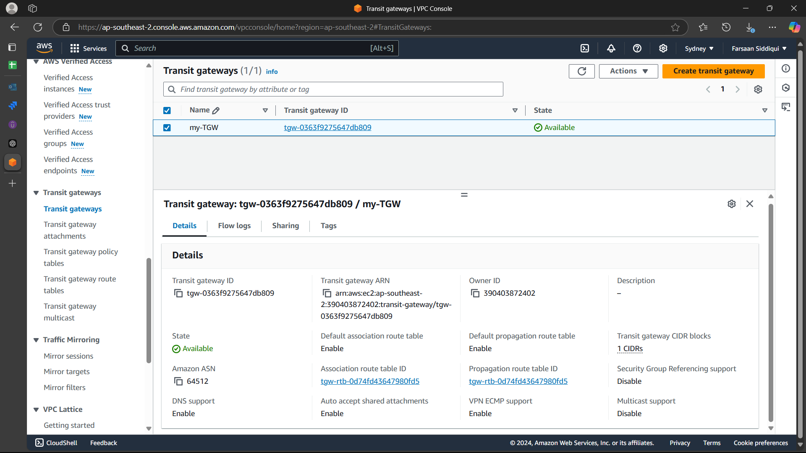

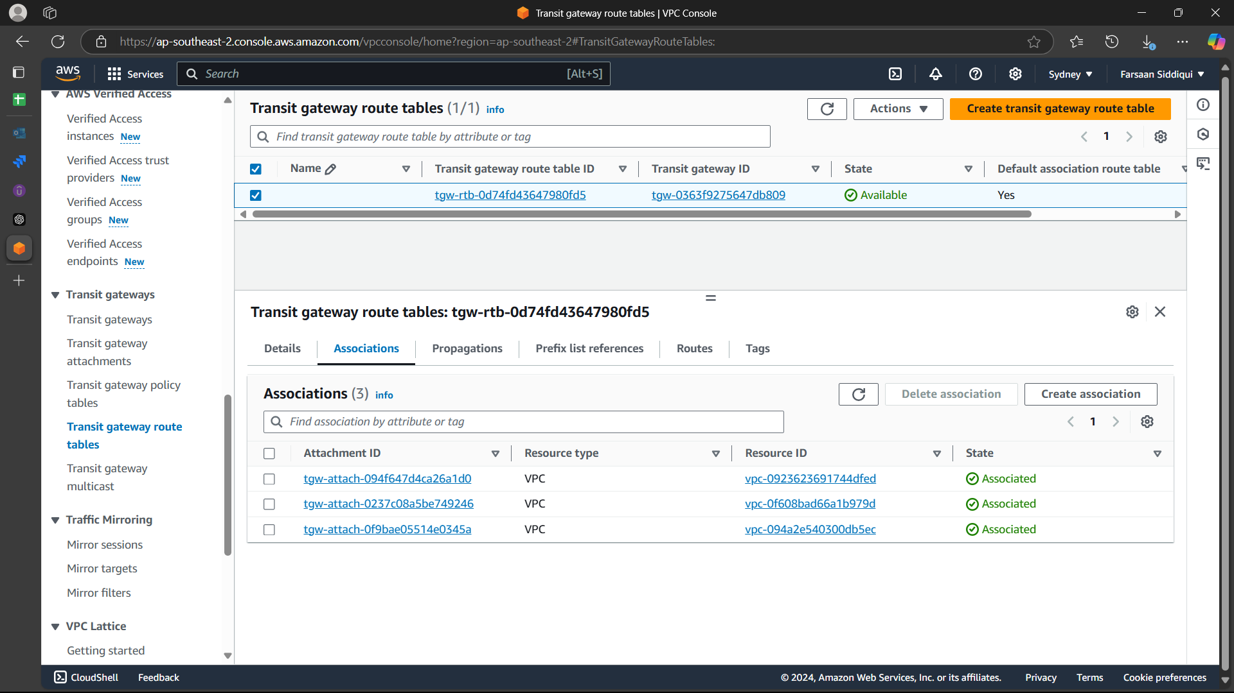

**>>****Setup VPC End Point.**